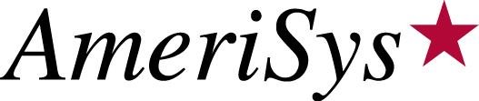
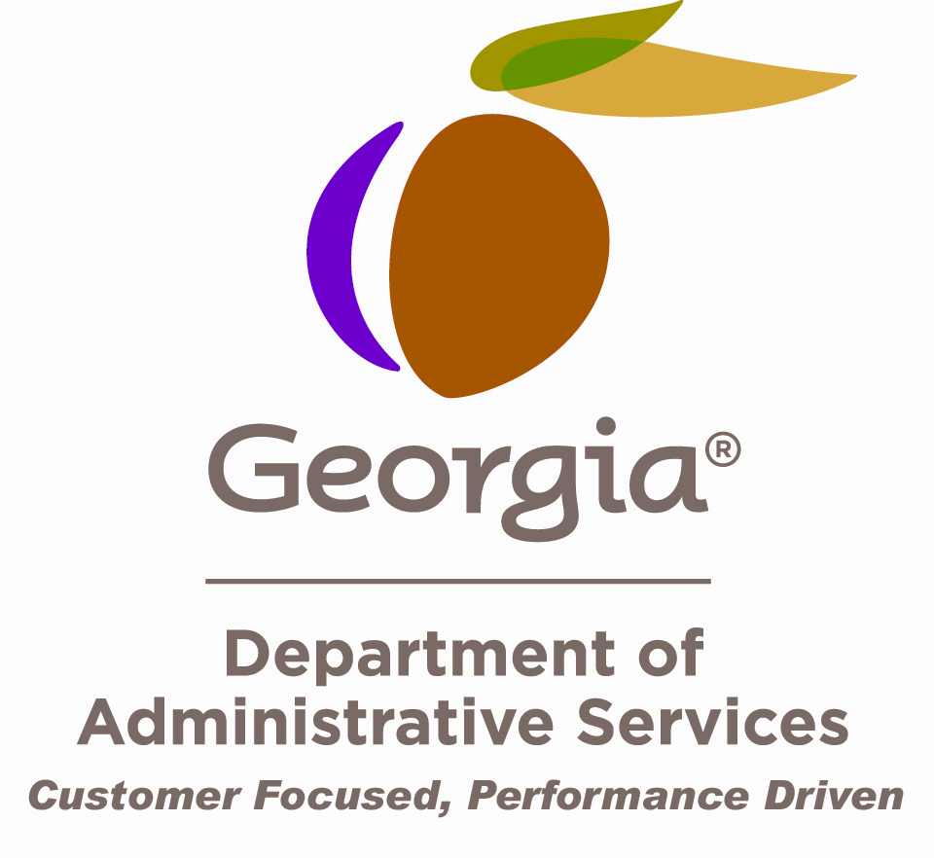

WC/MCO at a Glance

INJURED WORKER RESPONSIBILITIES

If you experience a workers' compensation injury, you should notify your supervisor immediately (no later than 24 hours).

The next step is to call AmeriSys Managed Care at 678-781-2848 or 800-900-1582 to speak with a case manager who can assist you in obtaining medical care, finding a physician or getting you the appropriate follow-up care. You will be asked to choose an authorized treating physician who will supervise your medical treatment to ensure you are receiving high quality, appropriate care.

EMERGENCY CARE

If, as a result of a work-related injury or illness, you require immediate medical attention, you should proceed to the nearest emergency medical care facility or call 911 for assistance.

DISPUTE RESOLUTION

AmeriSys Managed Care will respond to any dissatisfaction regarding a network provider or managed care service under your employer's plan. If you have a complaint, please contact AmeriSys Managed Care at 678-781-2848 or 800-900-1582. The Dispute Resolution Coordinator will discuss your complaint with the appropriate party.

The Dispute Resolution Coordinator will respond to you within 24 hours, or the next working day.

A written complaint regarding claims practices or provision of services concerning the Managed Care Plan or its network providers may be sent in writing to:

AmeriSys Dispute Resolution Coordinator
9 Dunwoody Park, Suite 106
Atlanta, Georgia 30338

If the dispute cannot be resolved within 30 days of a written notice, by the Managed Care Dispute Resolution Procedure, any party may request intervention by the State Board of Workers' Compensation.

DOAS Risk Management may become involved at anytime during the dispute process upon the request of the injured party.

Please Note: If your dispute involves the payment of benefits or aspects of your claims not directly related to the provision of medical care, contact Risk Management for assistance by calling 404-656-6245 or 877-656-RISK (7475) and select Option # 3.

Workers’ Compensation Managed Care Organization (WC/MCO) –Is an organization that is certified by the State Board of Workers Compensation to manage the medical aspect of your claim. After you have a work-related incident that requires medical attention, you must call AmeriSys, your WC/MCO for assistance with selection of a provider. The Triage Department will set you up and a Case Manager will assist you through your injury and rehabilitation and facilitate a prompt, appropriate return to work.

